16 Craft Fair Tips for Beginners: How to Run a Successful Craft Show Booth

One of my favorite pastimes? Attending fairs. Whether they are women’s fairs, book fairs or a craft fair – I love them all. I love going to craft fairs for several reasons, namely to get out of the house without my husband. Bahaha! I also enjoy meandering and browsing, taking my time to both appreciate and purchase other crafters works and to get new ideas for my own home.
If you are thinking of attending your first craft fair as a vendor, there are some definite do’s and don’t’s when it comes to setting up your booth and how you engage with your customers – and other vendors too!

TIPS FOR A SUCCESSFUL CRAFT FAIR
The obvious goal, when paying the entry fee to a craft fair, is to sell your wares and recoup your cost (and then some). But, you also want people to remember you and your name so that they can find you later on your Facebook page, your website or find you on Etsy etc. Take the following tips and see if you can’t walk out of your next craft fair feeling like a boss.

1. PRESENTATION!
Presentation is everything! Your buyer’s first impression will many times make or break a sale. When setting up, think of the ways your booth will appear to passersby. You want to offer a wide array of items, in a wide range of price points, without over crowding your table. This is not an episode of Hoarders, but you definitely want to utilize ALL space available to you – including vertical space.
Take table cloths (inexpensive flat sheets from Walmart work well also) to drape over the table, use wooden crates to add depth and “shelves”, use old opened suitcases for charm, invest in a mannequin, convert an old photo frame to have chicken wire stapled to the back for hanging items (with mini clothespins) etc… The more eye catching your booth (without being overcrowded) the better.

2. MIRROR, MIRROR, ON THE WALL
Provide a mirror! I can not tell you how many times I have left an item I might have purchased if I could have just seen it ON myself. Try to have a good sized mirror (full length if possible) with a frame instead of hand-held. Of course if a large mirror is not possible a hand-held mirror is better than nothing, but again – presentation is everything. If you don’t already have a cute, decorative mirror, watch for sales (or use your coupons!) at Hobby Lobby, Michael’s or Joann’s etc and pick one up!

3. ADVERTISE YOUR BUSINESS
I cannot stress enough how important it is to have business cards in multiple places. Have a stack at the front of the table and make sure your bags are pre-stuffed with your marketing materials such as business cards, FB VIP information, etc. By having your bags pre-stuffed with your contact info, you are ensuring that every customer that makes a purchase walks away knowing how they can continue to shop with you even after the event is over. If they do not make a purchase, you can also give them a business card from your handy dandy stack.
There are numerous places to find inexpensive business cards online. Make sure you include where to find you online and how to contact you.
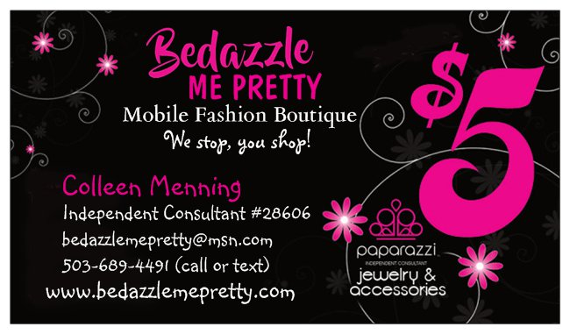

4. PRICE EVERYTHING
As a customer, I do not want to have to ask for a price. In fact most times I will not ask, instead I’ll just pass right on by. Don’t do that to your customers – or to yourself!
With Paparazzi, pricing your items is easy because it’s all $5.00. Just be sure that you have good signage. Print 8.5x11 signs in COLOR and have them laminated so they will last longer. This will also make them rigid so you can use clip on sign holders on your displays. Use a banner. You can get banners custom make at VistaPrint or Staples. They are large and eye-catching from far away so it will help to attract customers to your booth.
Want an even better way to price your items? Use your business cards AS your price tags (but also have some available in that stack). Scatter them on your table, up against displays, etc. This will not only announce the price of your items, but people are more apt to pick them up as they see them and hopefully stash in their purse, wallet etc. where they will find it again later down the road.

5. DON’T OVERSELL YOURSELF
Be available but not pushy. Make yourself busy in your booth by straightening, rearranging, or filling empty spots on your displays. This will allow you to be standing in your booth. (I try not to sit as it may come off as me being bored) This allows me to be present and available for questions, but in a way that doesn’t feel overly in-your-face to the shopper. Plus, I’m readily available to pay someone a compliment (great way to start conversations) and the customer won’t be afraid to “bother” me if they have questions!
Alternatively, engaging with your customers is key. When I shop I want to be left alone, but I also want to know that should I have any questions (do you have this in a different color? etc) that the vendor is accessible. When I am on the other side of the table however, my approach is different. Definitely make eye contact, smile and say hello, read the person’s reaction. Their body language will tell you if they wish to engage in further conversation or simply shop.

6. WHAT TO SELL?
Think small (ish) and think ahead! What kinds of things will people be needing in the next few months? In October, the best items would be pieces in Fall colors or Christmas related colors, whereas in March you might want to stock your booth full of items that would work well with Easter outfits, items in spring colors and perhaps even some items geared towards the 4th of July.
You also want to have a wide variety of items, in many different styles. The idea is to have styles & pieces that appeal to everyone. Many times the items you think won’t sell WILL! Maybe you personally don’t like wearing rings or bracelets for example. Well there are many people who love them so make sure you HAVE them! Don’t have only items you like or colors & styles that appeal to you. Remember…you are not selling to yourself, right?

7. WEAR YOUR ITEMS, IF POSSIBLE
ALWAYS make sure you are wearing your product. If you have a favorite pair of earrings that are not Paparazzi, leave them at home and wear a pair of Paparazzi earrings during your event. You are not going to sell jewelry that you are not willing to wear yourself. If you just have too many different items to wear without looking like a walking pegboard, try to display the items in the manner they would best be worn/used. A bold, chunky necklace hanging on a pegboard won’t get nearly as much attention as it would if it were aesthetically displayed on necklace bust. Better yet, display it with a cute shirt on a mannequin!

8. PACKAGING, PACKAGING, PACKAGING!
Spending a little bit of money to offer quality packaging goes a long way in the professionalism of your brand. The packaging does not have to be expensive to be effective. Paparazzi sells pink merchandise bags in the back office. Use these whenever possible. There’s something to be said about seeing lots of people carrying YOUR little pink bag around during an event. They are eye catching and people will remember it long after they’ve gone home. Also, be sure you are wrapping pieces individually with tissue before placing items in their bags. Not only does it keep items from tangling, but it’s more professional and a courtesy to your customer. It makes it look like you care about your product and want to see them enjoy it without the worry of it breaking before it gets home. Hobby Lobby has the best value on tissue paper (yes, even better than the Dollar store). Another nice touch is to provide care instructions, printed out on regular paper and cut to size (and be sure to include your business name for marketing purposes).
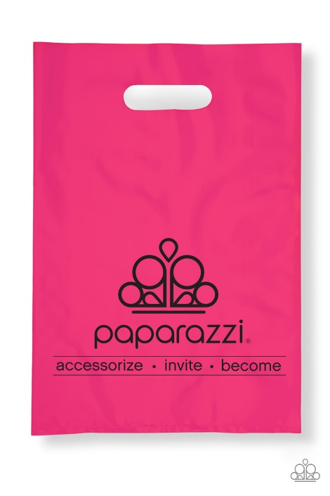

9. HAVE A MANNEQUIN, PROPS
I bought my mannequin at Joann’s Fabrics but you can pick these up at any craft store or look on FB Marketplace or Craigslist for a used one.
You should also have necklace busts for display if you’ve got the space. These are also available at any craft store or online. If you get them from Joann’s, make sure you use their 40% off coupons. You can also find them on Amazon, or www.storesupply.com.
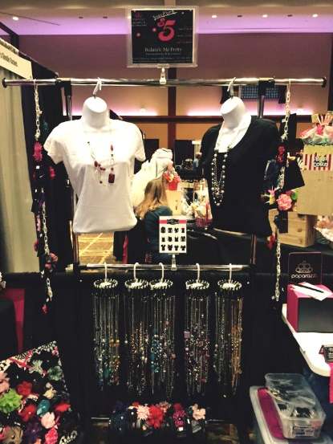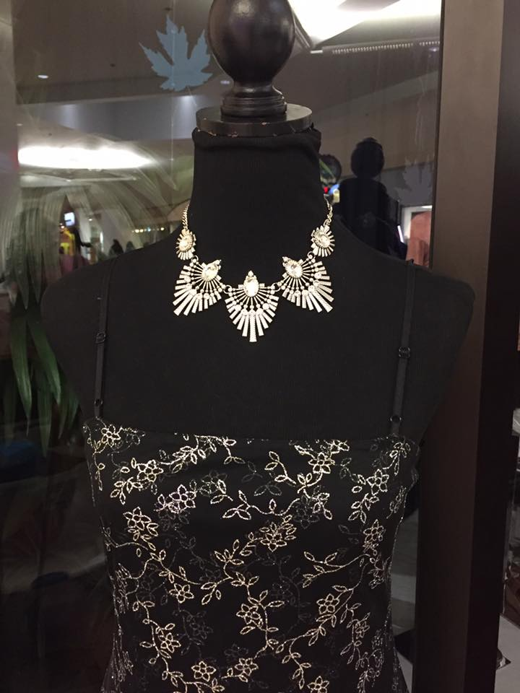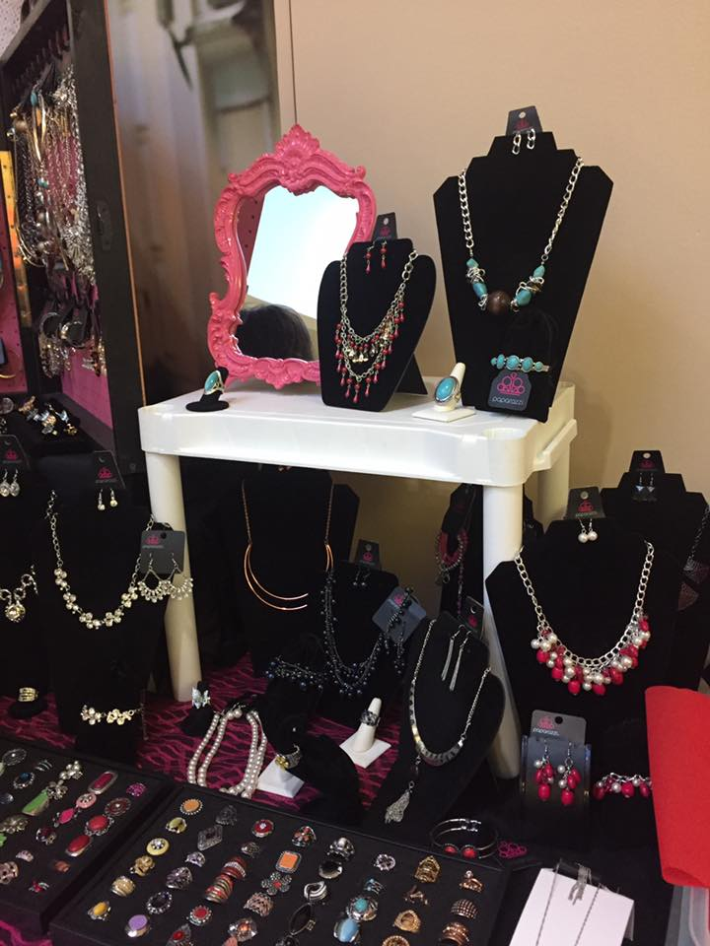

10. ACCEPT CREDIT CARDS!
If at all possible, accept credit cards (Square is a great tool) and advertise that you accept them. Take up just a bit of your space to advertise a sign like mine below. I whipped this up using Canva, a free online photo editing tool. I added some of my most popular designs to draw people in. Create one yourself to convey that not only do you accept cash and credit cards, but you have other colors available as well.
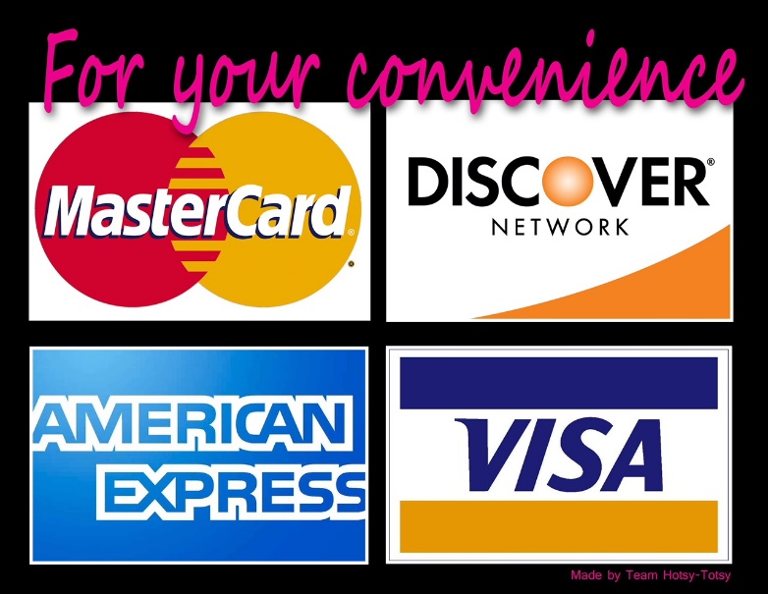

11. Have Your Website Available For Browsing
When presenting at an event, you only have a limited space available to you. Why not have a laptop set up on your table with your website pulled up for your customers to browse for more options. Maybe your inventory is small to start out or maybe you have just a small informational type of booth? Why not let your customers look at all the online options you have available for them to shop anytime?! Keep it open to the page with your most popular design(s).

12. OFFER A GIVEAWAY
A great way to gain leads or contacts is to offer a giveaway that your customers can enter in exchange for their contact information. Have a box and lead slips on your table so that they can enter to win. Have them give you their email address and Facebook name. Post that you will be announcing the drawing on Facebook so if they would like to see if they won, they could join your FB VIP group. You can draw the winner LIVE and ask them to tune in to watch. This is exciting for the customer AND it gets them into your group so they can shop with you more.

13. MINGLE!
By mingling I don’t necessarily mean with your customers. Sure, you want to mingle with them too, but if you take the time to get to know your neighbors (I hope they’re cool) you might get information about other upcoming craft shows, item placement tips and tips on pricing etc. Also, you take note of each other’s inventory. They can send people your way and you can send people theirs!

14. PAY ATTENTION!
I feel like this should not have to be said, but here goes. One of the reasons I like to walk around in my booth during an event is because it keeps me from browsing on my phone. Nothing is worse than ignoring your prospective customers or looking bored. If you are up and moving, working, talking to people, etc it shows that you are attentive and open for business.

15. EDUCATE
If you have someone with you at the table (your older children, a friend etc) make sure they have, in the very least, basic answers to any questions that may arise. Color choices, care instructions, etc. This way if you step away for a restroom break (which you should try to do at off-times) they will have those answers.

16. DON’T FOCUS ON THE SALES
Sure, we are all here to make money, but try not to focus on the sales. Focus instead on having fun, meeting new people and learning from the experience.
Having a booth at an event is a lot like going hunting or fishing. You spend money on supplies (entry fees) and you spend all day trying to catch a buck (or make a buck). Even if you come home empty handed, you have gained knowledge, experience and you’ll be more prepared going in next time. What a great reminder!

